**Pending Games**

**Design Document for**

**Rolly Ball**

**License info…**

**Written by Anthony Bridgett, Michael Savaglia & Daniel Prueitt**

**Version 1.0**

**Monday, 17th October, 2016**

**Main Menu screen (Work in progress graphics)**

The menu screen will contain 4 buttons total, one to mute and unmute all sound throughout the game. One button to launch game mode 1, another for game mode 2, and a final button to show local hi-scores.

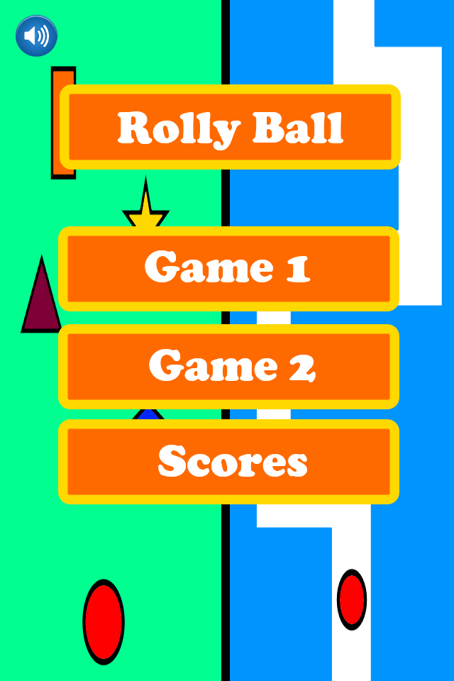

**Game Modes**

**Mode 1 –** Dodging falling objects by moving left and right, using a swiping motion.

|  |  |
| --- | --- |
|  | * You control the ball at the bottom, you move the ball left and right through touch to avoid the other falling shapes. * The ball will be fixed to the location that is being touched, only horizontal movement. * Difficulty can be selected before playing. * Objects are dropped randomly, there are more objects moving at a higher speed with the higher difficulties. * Score increases with every shape dodged. * There will be collectables that occasionally drop to increase score. |

**Mode 2 –** Navigate the ball through the maze

|  |  |
| --- | --- |
|  | * Utilises same controls as mode 1. * The maze moves down towards you and if your ball touches any part of the maze boundary, that will trigger game over * The speed of the maze increases as time advances. * Collectables will be in harder to reach areas. * Again there are three difficulties that determine the starting speed of the maze. * The score increases with distance travelled in the maze (making all difficulty scores comparable). |

**Extra Features**

This small list of features will be implemented given the amount of time left over after the main two game modes have been implemented.

* Achievements
* Swipe left and right to change menu screens
* Global high scores
* Extra levels for game mode 2